You are here: Home / Vol. LII No.28 / Ebola Virus Disease A Cause for Concern?
HEALTHCARE

Ebola Virus Disease A Cause for Concern?
12 Oct 2014 0 comments Share |
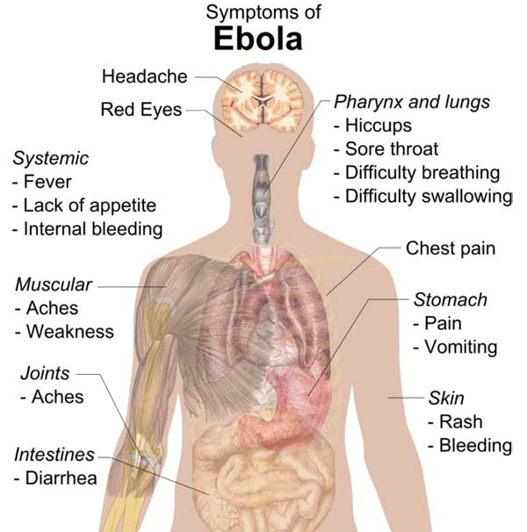
Symptoms of Ebola
By DR. ANIS ANSARI
Ebola Virus Disease (EVD) has caused a World Wide panic for the last several months. It has been in the news daily. It was limited to West Africa but has started to spread to Nigeria and Senegal. Centre for Disease Control (CDC) in conjunction with World Health Organisation (WHO) has tallied the numbers. As of 14 September, the total count was 5347 cases with total death count of 2630 with fatality rate close to 50 per cent. In the last one month the number has doubled. Sierra Leone and Guinea being the most affected with largest number of cases. Risk of this in the US is very low even though two cases have been found in the health care workers.
Predictive models have varied as researchers struggle to estimate an outbreak on a size and scale never seen before with Ebola. A separate worst-case scenario modelled last month by researchers at the University of Tokyo and Arizona State University predicted that there would be as many as 277,124 new cases by the year’s end.
“In the three weeks since then, the numbers have doubled so all three countries are still reporting cases on a steep upward curve,” Epstein said. “We don’t have a good idea of how big this epidemic will become.” If the response is not increased, there may be as many as 5,000 new cases a week, he said. The US has made commitment of $1 billion for the response to Ebola with use of military transport as well as troop for this purpose in order to control this epidemic.
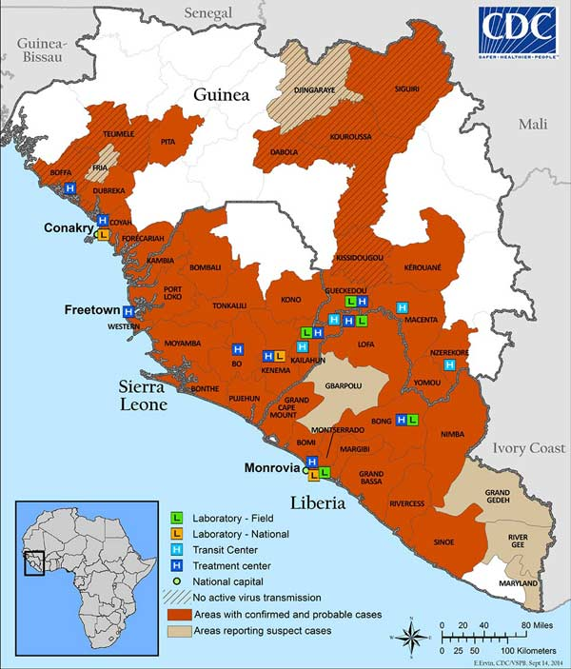
Map of infected areas of West Africa
BACKGROUND
Ebola virus causes acute, serious illness which is often fatal if untreated. EVD first appeared in 1976 in two simultaneous outbreaks, one in Sudan and the other in Democratic Republic of Congo (DRC). The latter occurred in a village near the Ebola River, from which the disease takes its name.
The current outbreak in West Africa with the first case registered in March 2014, is the largest and most complex Ebola outbreak since the Ebola virus was first discovered in 1976. On 8 August, 2014, WHO declared this outbreak a Public Health concern of international proportions.
TRANSMISSION
It is thought that fruit bats are the natural Ebola virus hosts. Ebola is introduced into the human population through close contact with the blood, secretions, organs and other bodily fluids of infected animals such as chimpanzees, gorillas, fruit bats, monkeys, forest antelopes and porcupines found ill or dead in the rainforest. Some of the above like fruit bats are prevalent in these countries and found inside homes. It can spread through human to human via contact with body secretions, materials like bedding, clothing and contaminated fluids.
Health care workers have frequently been infected while treating patients with suspected or confirmed EVD especially when precautions are not strictly followed. It is not transmitted by air.
SIGN AND SYMPTOM
Symptoms of EVD are fever, fatigue, muscle pain, headache and sore throat. This is followed by vomiting, diarrhoea, rash and impaired kidney and liver function as well as internal and external bleeding like oozing from gum or blood in the stool. Bleeding from mucus membranes can start within 5 days of contracting the infection. Average time between contact and appearance of symptom is 8-10 days but could vary from 2-21 days.
DIAGNOSIS AND TREATMENT
There are many tests that can be performed to test for Ebola virus. However many of these may not be available where it is needed most. There is no proven treatment or licensed vaccine available so far. Vaccine is in process of being tested. Treatment is supportive care and rehydration done with both oral and intravenous fluid.
PREVENTION
Prevention is in reducing the wildlife-to-human transmission by avoiding infected animals, and consumption of their meats. Protective gloves, clothing and thoroughly cooking meat before consumption are very important elements in prevention.
Reducing risk of human to human transmission is possible by using glove and frequent hand washing while handling people with Ebola symptoms or their close contact. Outbreak containment measures including prompt and safe burial of the dead, identifying people who may have been in contact with Ebola and monitoring health contact for 21 days. The importance of separating the sick from healthy to prevent spread, the importance of good hygiene and maintaining clean environment are also very important.
CONCLUSION
EVD is an epidemic with potential to spread to rest of the world. This epidemic is spreading fast in West Africa. There is worldwide effort to find vaccine and contain the disease by mobilising resources needed to accomplish this task.
[ANIS ANSARI, MD, FASN may be reached @ anisansri5@gmail.com]
Also See
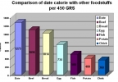

Dates for Health
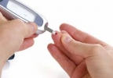

Fasting may Ward off Diabetes
- See more at: http://radianceweekly.in/portal/issue/will-sc-guidelines-contain-fake-encounters/article/ebola-virus-disease-a-cause-for-concern/#sthash.1px55wj5.dpuf

